**Dabane Water Workshops**

**Complaints Handling and Feedback Mechanism Policy**



Contents

Introduction 2

Policy statement 2

Scope 3

Commitment 3

Resources 4

Visibility 4

Responsiveness 4

Accountability 4

Definition of terminology 4

Classification of complaints 5

Policy Implementation 6

File Storage and Data Management 10

Reporting and responsibilities 10

Complaints Handling and Feedback Focal Person 10

Director 11

Immediate manager to the complainant 11

Policy monitoring and review 11

Annexes 12

Bibliography 14

# 

# Who is Dabane

# Introduction

The Complaints Handling and Feedback Mechanism Policy (CHF) is developed by Dabane to strengthen its transparency and good relationship with relevant stakeholders, individuals, programme participants and partners. The policy sets forth the conditions and procedures for complaints handling for accountability as a means of taking responsibility for listening to the needs, concerns and views of its supporters, donors, partners and the communities it serves. Dabane will strive to improve the quality, learning and effectiveness of its programs and places its partners and programme participants it serves at the centre of its work.

This policy works in conjunction with other international statutory instruments such as:

* Convention against Torture and Other Cruel, Inhuman or Degrading Treatment or Punishment article 27 (1)
* International Covenant on Civil and Political Rights -Article 49
* Convention on the Elimination of All Forms of Discrimination against Women
* The Humanitarian Accountability Partnership Tool 26 of 2007 Standard in Humanitarian Accountability and Quality Management.

As we as Dabane internal policies such as:

* The Dabane Staff Code of Conduct.
* Safeguarding Policy
* Information Sharing
* Programme Participants Protection policy
* Participation Policy

# Policy statement

Dabane is committed to the prudent handling of complaints and provides a platform to identify areas of service that need improvement and respond to and resolve individual, group, community, stakeholders and partners misunderstandings. Dabane will strengthen the relationship between the organization and the communities being served through active participation by all parties concerned in a free and transparent manner to achieve the organizational goals and planned activities.

# Scope

The Policy aims to ensure consistency in operational processes and also sets out how complaints from individuals, programme participants relevant stakeholders and partners should be heard, managed and resolved consistently to save time and effort.

**Principles of the policy are:**

* Recognition of the dignity and rights of project beneficiaries, including the right of people to express their opinions and concerns.
* Holding organisations and relevant stakeholders to account against the promises and commitments made to the communities they support.
* Improved impact and effectiveness of programmes e.g. through early participatory identification and management of issues and risks; protection of staff by providing them with ways to investigate and respond to issues; continuous learning and improvement; and enhancing public standing by being seen to be a ‘listening organization.

# Commitment

Dabane is committed:

* To efficient and fair resolution of complaints by programme participants and stakeholders. It acknowledges their right to complain and actively solicit feedback from them.
* To deal with complaints in accordance with the Complaints Handling and Feedback Mechanism Policy and Procedure.
* To engage programme participants or stakeholders on appropriate ways to effectively handle complaints.
* To ensure that the intended programme participants, stakeholders and staff understand the complaints handling procedures.
* To encourage programme participants who would want to provide feedback to Dabane to lodge feedback directly to the organization’s Complaints Handling Focal Person.

# Resources

Dabane will provide, when necessary, adequate resources, as practicable as possible, for complaints handling with sufficient levels of delegated authority. Dabane shall further identify the need for complaints handling system to be reviewed regularly.

# Visibility

Dabane Trust complaints handling policy shall be available to programme participants and relevant stakeholders for input discussion and approval before implementation.

# Responsiveness

Complaints shall be dealt with as quickly as possible and the complainants shall be treated courteously.

# Accountability

Dabane processes shall take account of programme participants, stakeholders and community members.

Dabane shall have appropriate documentation and reporting of the complaints handling process against documented indicators as set out by the Humanitarian Accountability Partnership Tool 26 of 2007 Standard in Humanitarian Accountability and Quality Management.

# Definition of terminology

A **complaint** is an expression of dissatisfaction about the standard or quality of assistance being provided and is related to the actions or lack of actions taken by a staff, project, community member or partner organizations that directly or indirectly causes distress.

**Complaints** are directly associated to the commitments made by an organisation, in terms of what and how it promises to deliver assistance and give support. People on the receiving end of assistance and support have the right to complain if standards are not met, if assistance is not appropriate to them or are not as promised to them by implementing organisations or when there are serious breaches of codes of conduct. A **formal** complaint shall **demand** a response and **the responsible authority** receiving a complaint **has a duty** to respond **to the complainant.**

A **complainant** is any **party** who **conveys a concern,** **allegation/expression** or **information** indicating **fraud**, **corruption** or **misconduct.**

An **Investigation** is a process **designed to gather and analyse** information in order to determine whether **an act** of **fraud, corruption,** or other **misconduct has occurred** and if so, the party or **parties responsible.**

# Classification of complaints

Dabane identifies the following categories of complaints:

**‘Valid’ complaints** – defined as “an expression of dissatisfaction directly associated to the commitments and promises made and therefore within the control of the organization”.Valid complaints include**:**

1. **‘Non-sensitive’** complaints e.g. complaints relating **to project** activities **or funding.**
2. **‘Sensitive’** complaints e.g. **abuse** and **exploitation,** including **sexual abuse** and **exploitation**, **staff misconduct**, **misuse of funds** and **fraud.**

**‘Non-valid’ complaints** - usually relate to issues **outside the control** of **Dabane Trust.** Dabane shall practice good communication skills with the communities, partners and stakeholders to help reduce non-valid complaints, preventing false expectations being raised. Dabane might receive some ‘non-valid’ complaints from time to time, especially in contexts where there are limited outlets for expressions of dissatisfaction.

# Policy Implementation

1. Receiving Complaints:

Dabane, project beneficiaries, partners and relevant stakeholders shall provide a system/method through which complaints can be submitted. The system will include letters, text message, telephone, email, suggestion box etc.

1. Processing a Complaint

Dabane shall establish the ‘type’ of complaint and the procedure to be taken in dealing with the complaint. Dabane shall classify complaints as sensitive or non-sensitive in order that complaints are dealt with in-line with the appropriate procedure. Different types of complaints shall require different approaches in handling them: if complaints are sensitive, they might fall under police investigations; if non-sensitive, the complaints may most likely be resolved more immediately with necessary changes made in-line with programme documentation.

Once Dabane has decided on how the complaints shall be handled, the complainants will be given acknowledgment that their complaints have been received. They will also need to be given an explanation of how the complaints will be dealt with and what they could expect from the process. To manage expectations of people submitting complaints, timeframes for giving a response should be established and clearly communicated to users. For non-sensitive complaints, it would be expected that a response is given within one working week, whereas for sensitive complaints a longer timeframe would be expected because of more complex investigation processes. A clear indication of this will be communicated to the complainant. Where possible, responses will be given in both verbally, in writing, and recorded by Dabane so that it is possible to check that a response has been given and acted upon.

1. Review and Investigation

Complaints will be reviewed and investigated by management to determine their validity; to clearly identify what commitment or promise has been breached; and to decide what action needs to be taken in response. The decision on how to investigate complaints lies with the delegated staff responsible for processing complaints. The Board will be kept abreast of what is happening by the Director. For non-sensitive complaints it is typically a Complaints Handling Focal person who will review the complaint in line with programme documentation and deal with the complaint directly.

Serious sensitive complaints may require that investigators are capacitated to carry out specialist investigations in the way that does not harm but maintains the integrity of the organization e.g. sexual exploitation and abuse cases. Where the complaint relates to a criminal or legal issue, it may not be handled internally but by the authorities or go through the local legal processes instead (e.g. fraud and corruption cases which breach local or national laws).

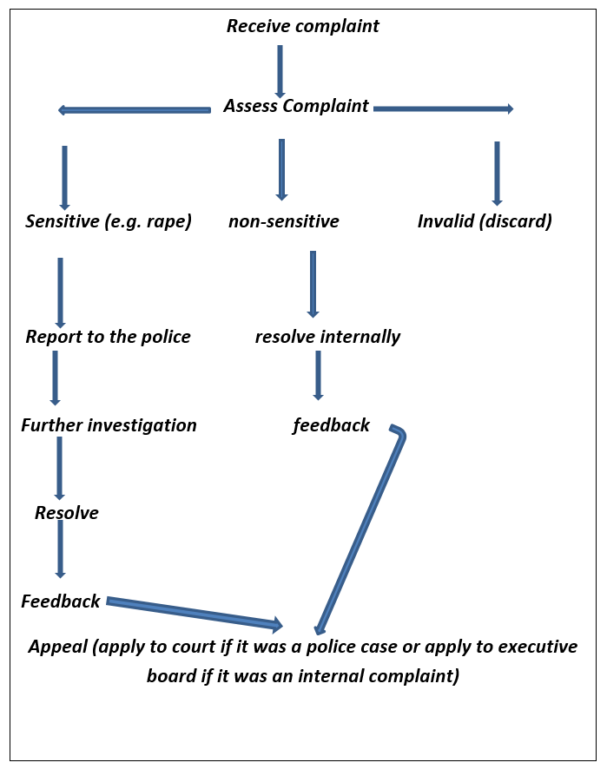

1. Response and Action

From the result of a review and investigation on complaints, steps will be taken by Dabane to amend or change strategy in order to improve the situation and resolve the issue. Dabane shall communicate key findings of the review and investigation processes with the complainants and keep them appropriately informed of what actions will be taken as a result of the decisions.

1. Appeal Process

If the response is not accepted by the complainant and a resolution cannot be reached between the parties concerned, the complainant may wish to appeal against the response. The appeal process will re-examine the investigation process already taken and determine whether to uphold the original decision or make a new decision based on the findings of this review.

An appeal process shall be clearly defined by Dabane, programme participants, partners and relevant stakeholders when it should be used; how it will work and who will be involved in it. The appeal process will check whether the initial decision or response was appropriate.

1. Resolution

Dabane shall aim to reach a long-lasting agreement between all parties involved in the complaint and most importantly, the complainants shall be satisfied that the complaints were dealt with fairly, appropriately and that the actions taken will offer solutions.

1. Tracking and Recording and monitoring Complaints

In order for Dabane and partners to monitor and manage complaints received, a tracking system and recording key stages of any complaint is necessary. Through participation by programme participants, stakeholders and staff members, it will be necessary important for Dabane to track how many complaints are received and by whom, from where and from whom, about what, when and how it has responded to the complaints and measures taken.

# File Storage and Data Management

1. A complaints register shall be securely kept by Dabane to prevent unauthorized staff members from gaining access.
2. The Complaints Handling and Feedback Focal Person shall not be permitted to take complaints records outside Dabane t offices without authority.

# Reporting and responsibilities

## Complaints Handling and Feedback Focal Person

The Complaints Handling and Feedback Focal Person shall:

* Ensure that information of complaints is kept up to date and available at all times;
* Ensure that the process for making complaints is easy for complainants to access and understand;
* Acknowledge complaints in a timely manner, address complaints promptly and according to the order of urgency and keeps the complainant informed throughout the process;
* Manage the complainant’s expectations by explaining the complaint handling process, what the organization can and cannot do, the timeframes for dealing with the complaint and when they might expect a response;
* Deals with complaints in an equitable, objective and fair manner;
* Clarifies the key issues of the complaint with the complainant;
* Consults people within the organization who have expertise relevant to the issue;
* Ensures the principles of procedural fairness are maintained by providing the affected parties with an opportunity to give their side of the story and to comment on any adverse views;
* Gives reasons for any decisions made, any changes that have resulted from the complaint and details of any remedy;
* Keeps personal information relating to complaints confidential;
* Ensures responses and outcomes of complaints are recorded, filed and reported to management and monitor implementation of remedies and actions to improve practices; and
* Analyses complaints to identify recurring themes and trends and reports these to management to assist with the organizational continuous improvement programs.

## Director

The Dabane Director has ultimate responsibility for the Complaints Handling and Feedback Focal Person and he/she may be involved in the Appeals process. If the complaint is against him/her, then there may be a need to consider external parties (e.g. the Board of Trustees and the executive committee) as an authority at which to lodge the complaint.

## Immediate manager to the complainant

The Complaints Handling and Feedback Focal Person will usually be involved in the process but for sensitive issues, it might be necessary to rely on the Director and Programmes Manager.

# Policy monitoring and review

In order to determine the functionality of the CHF policy as intended, Dabane shall build in a monitoring and review process of the policy. Monitoring shall be used to track and reflect on the complaints, the access points, the formats used, the investigation processes and the responses given. This shall constitute checks on how different aspects of the mechanism are working, and in particular on whether users understand their rights, and are able to use and understand the system, and also suggest ways to improve it. In addition, a full review of the system shall be carried out periodically to examine the system for any bottlenecks in processing or responding to the complainants.

The Complaints Handling and Feedback Policy will be shared with programme participants to find out whether they are aware of their rights to provide feedback and/or complaints and how.

# Annexes

1. Complaint Collection Forms

This form may be used by project staff as a way to record verbal complaints received from community members during field visits.

|  |  |
| --- | --- |
| **Part 1: To complete with complainant** | |
| **Date:**  Date complaint is received |  |
| **Personal Details:**  • Name and contact details of the  complainant  • Age  • Sex – male or female |  |
| **Project Details:**  Name / reference no. of project or programme  Ward  Village |  |
| **Nature of Complaint:**  Brief outline of the complaint | **Tick where appropriate**   |  |  |  |  | | --- | --- | --- | --- | | sensitive | Non-sensitive | valid | Non-valid | |  |  |  |  | |
| **Detail of the Complaint:**  A detailed description of the complaint the person  has made |  |
| **Who received the Complaint:**  Name of person who received the complaint |  |
| **Part 2: For office use and feedback to complainant, as appropriate** | |
| **Outcome of Complaint:**  Outline of what action was taken and what has happened as a result of the complaint |  |
| **Comments:**  Any further comments e.g. follow-up action recommended as a result of the complaint such as a change to current policy or procedures. |  |

**CHFP – APRIL/15**

# Bibliography

<http://www.hapinternational.org/pool/files/hap-annex-3.pdf>

<http://www.hapinternational.org/pool/files/wv-sri-lanka-community-complaints-handling-cards.pdf>

<http://www.drc.dk/relief-work/humanitarian-accountability-framework/complaints-mechanismhandbook>

<http://www.hapinternational.org/pool/files/cafod-complaints-handling-mechanism-chm-guide-v1-0-en.pdf>

<http://www.ombudsman.gov.au/pages/publications-and-media/better-practice-guides/complaint-handling.php>